A man throws an object with a mass of 1642 grams horizontally from a cliff with an initial speed of 2.4 m/s, knowing the height of the cliff as 27m, ignoring air resistance, calculate:

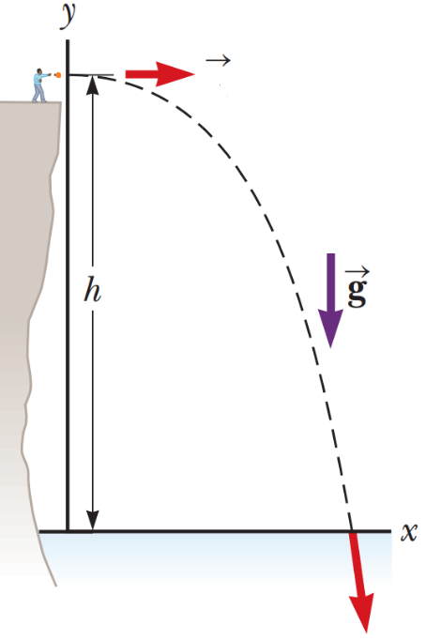

1. The vertical speed at which the object will hit the ground
2. The time it takes for the object to reach the ground
3. The kinetic energy of the object just before impacting the ground
4. How far the object will travel horizontally